**GitHub CP Submission**

**22F-3740**

**22F-3673**

1. **Repository Link:**

[**https://github.com/Blasty11/22F3740_22F3673**](https://github.com/Blasty11/22F3740_22F3673)

* **Create Repo:**

[**https://github.com/Blasty11/22F3740_22F3673.git**](https://github.com/Blasty11/22F3740_22F3673.git)

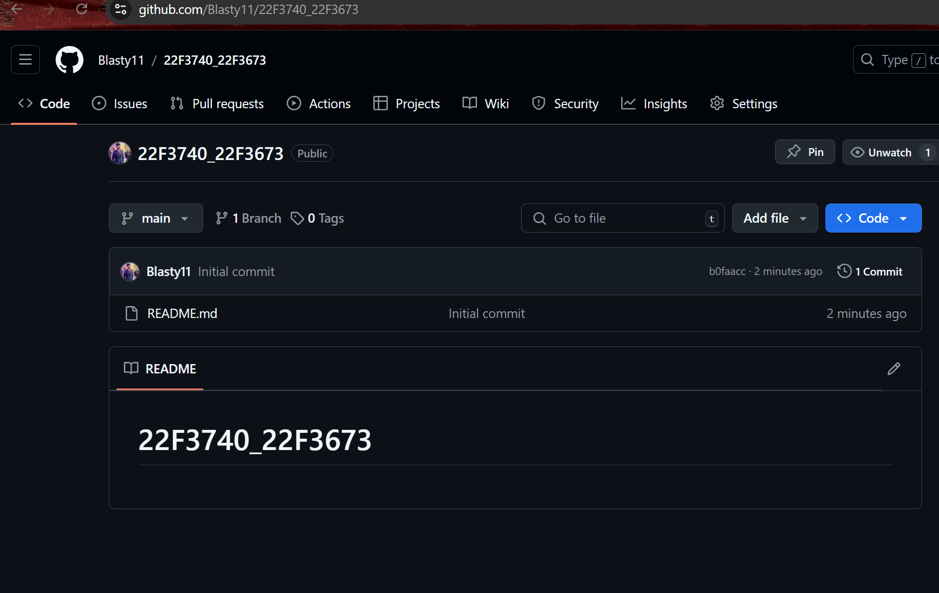

* **Git Command:**

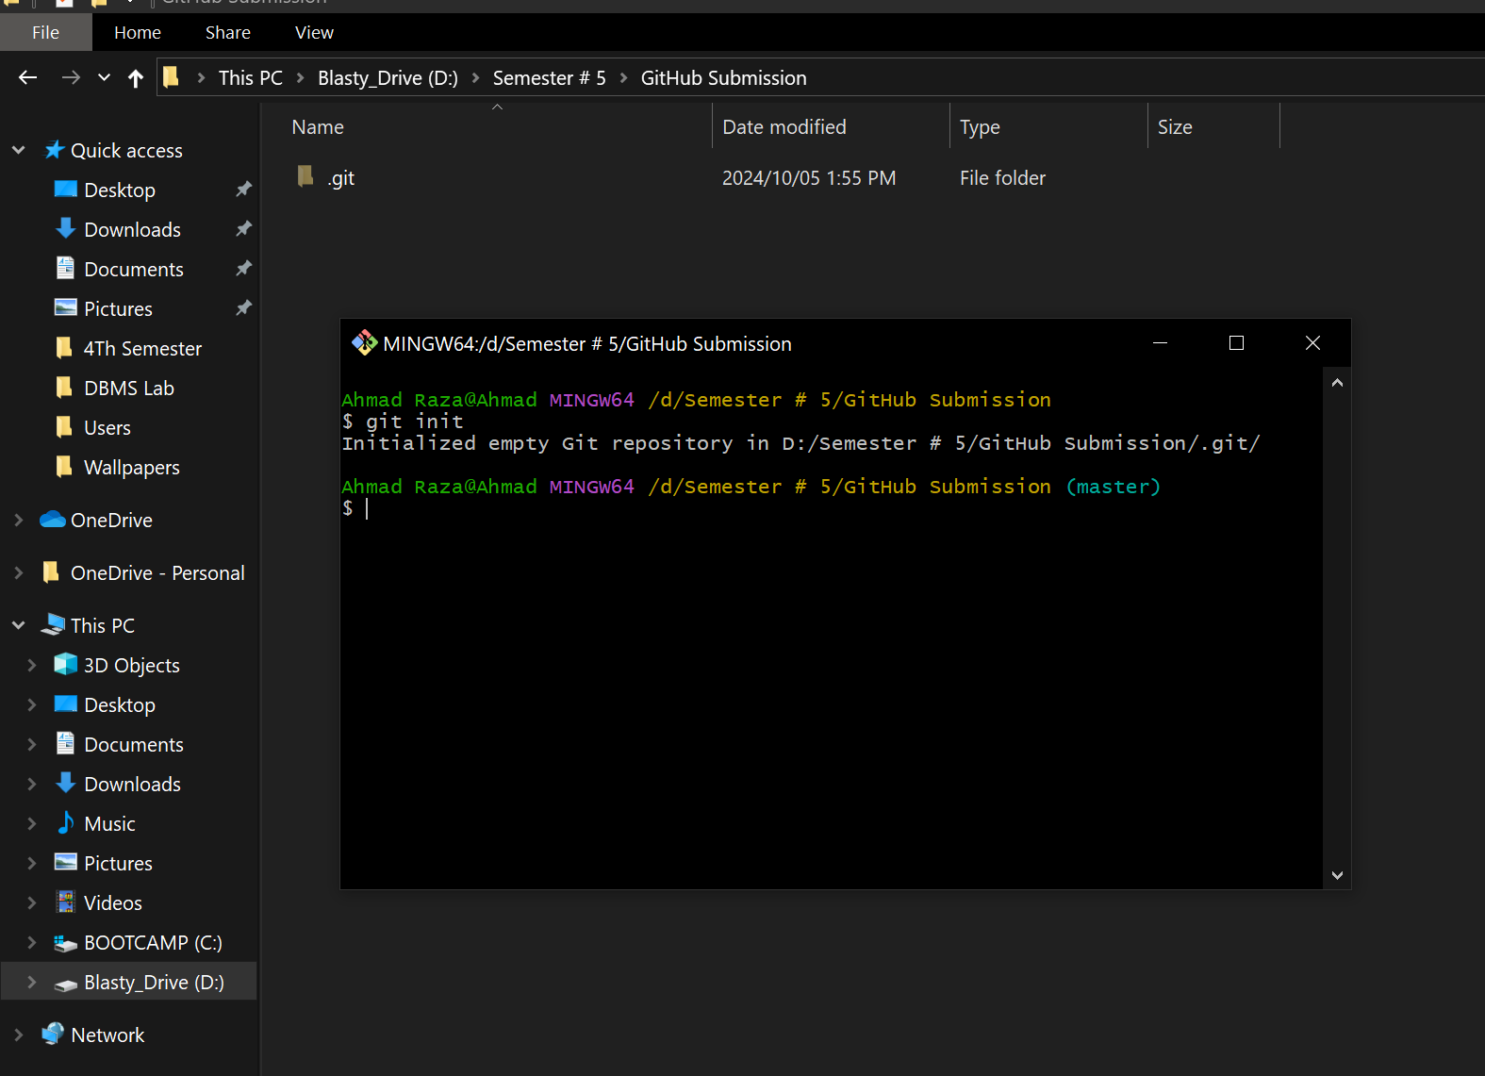

* **Init and Origin Command:**

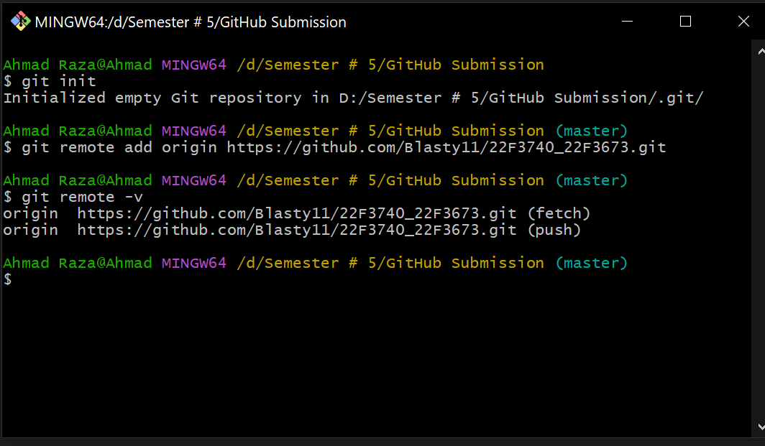

* **After Push and Commit:**

